**JACOCO REPORTS**  
1.Ticket Service

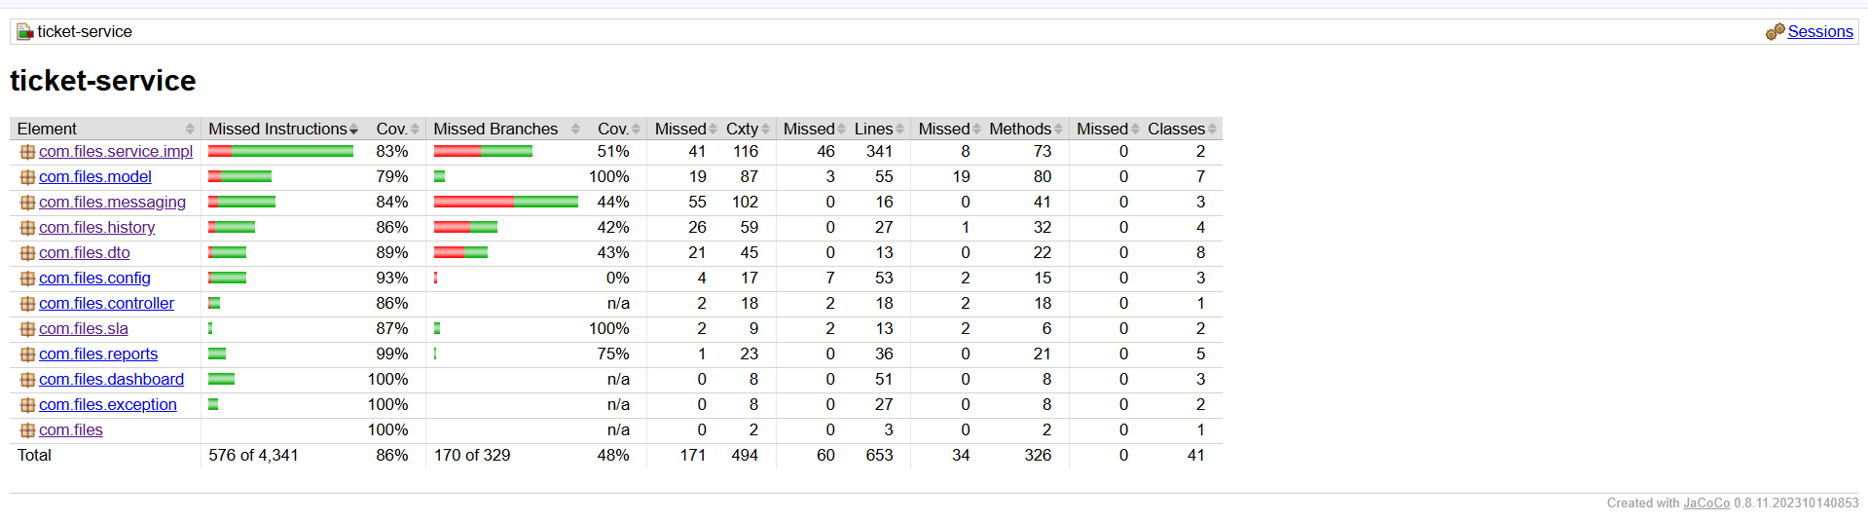2.User Service  
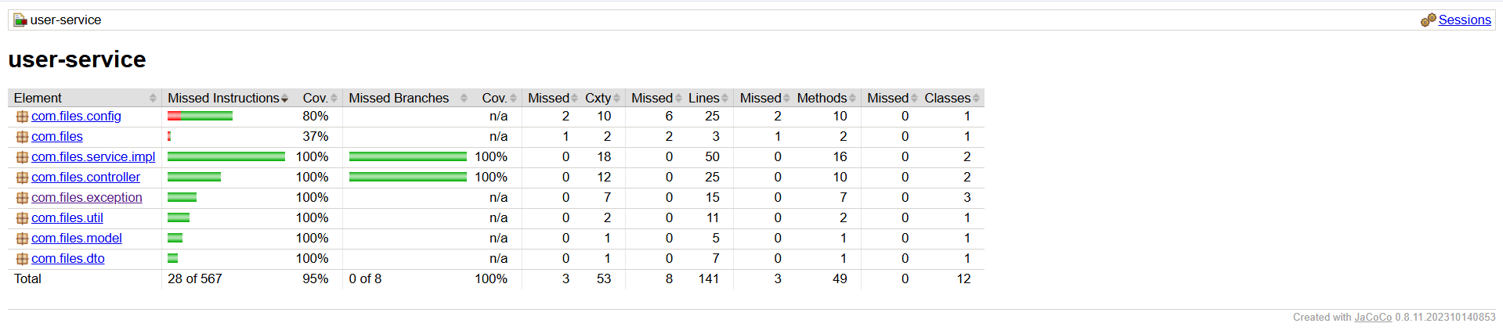

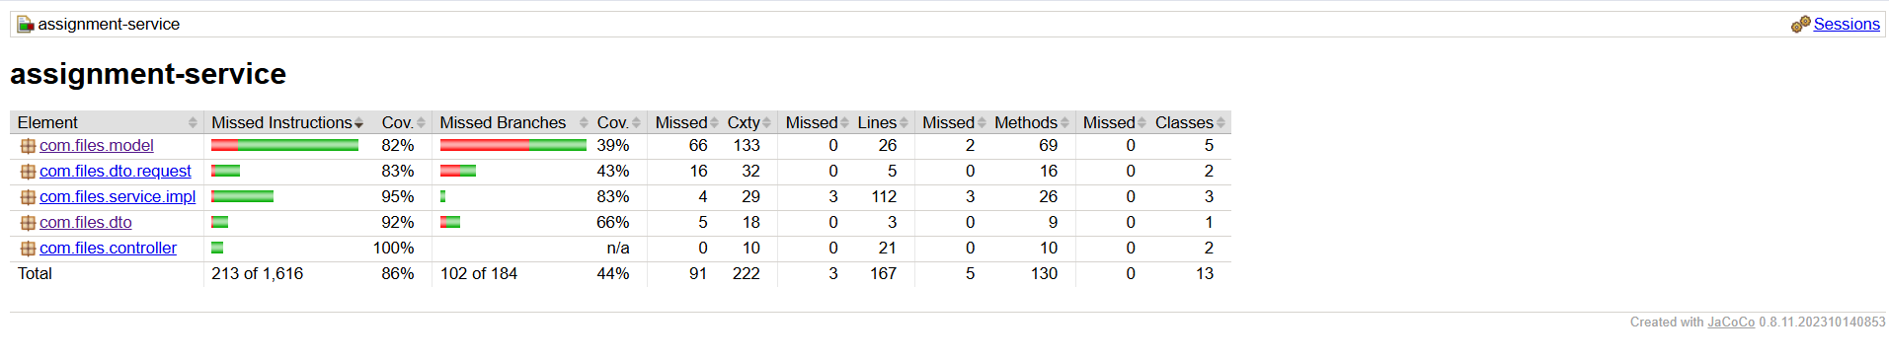3.Assignment Service

**EUREKA SERVER**

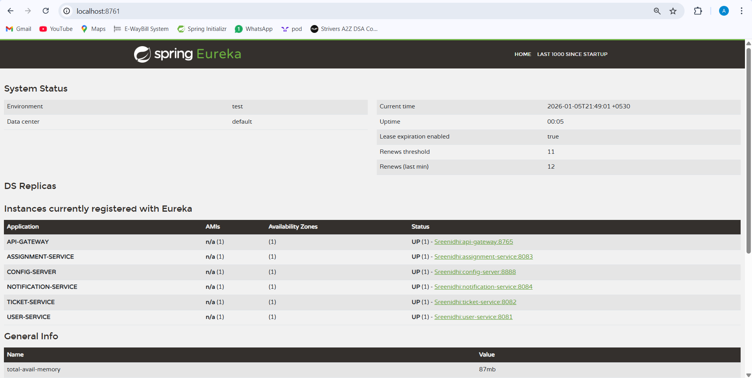

**CONFIG SERVER**

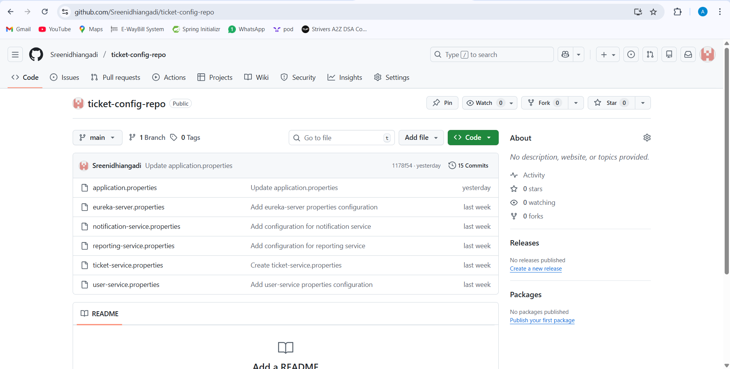

**SONAR QUBE**

1)User Service  
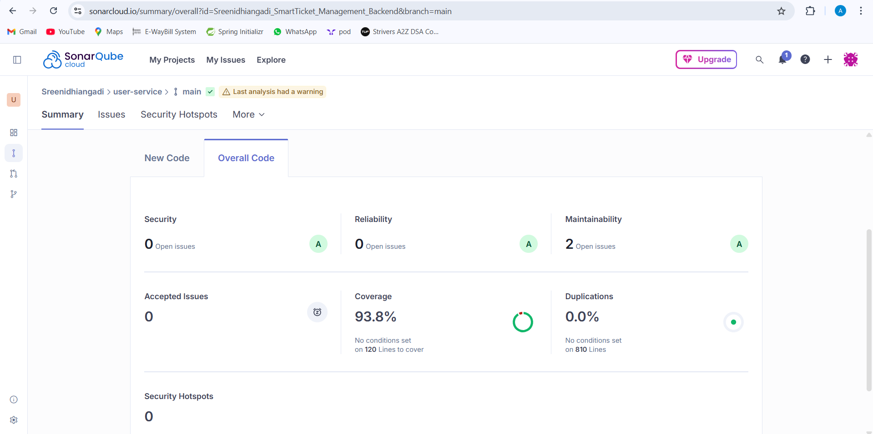

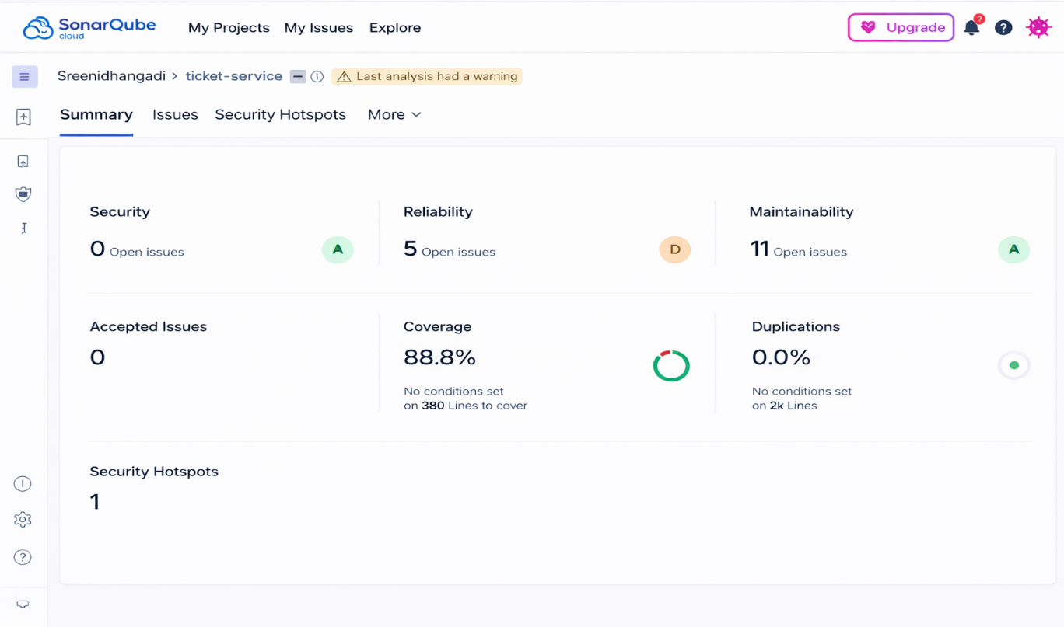2)Ticket Service

3)Assignment service

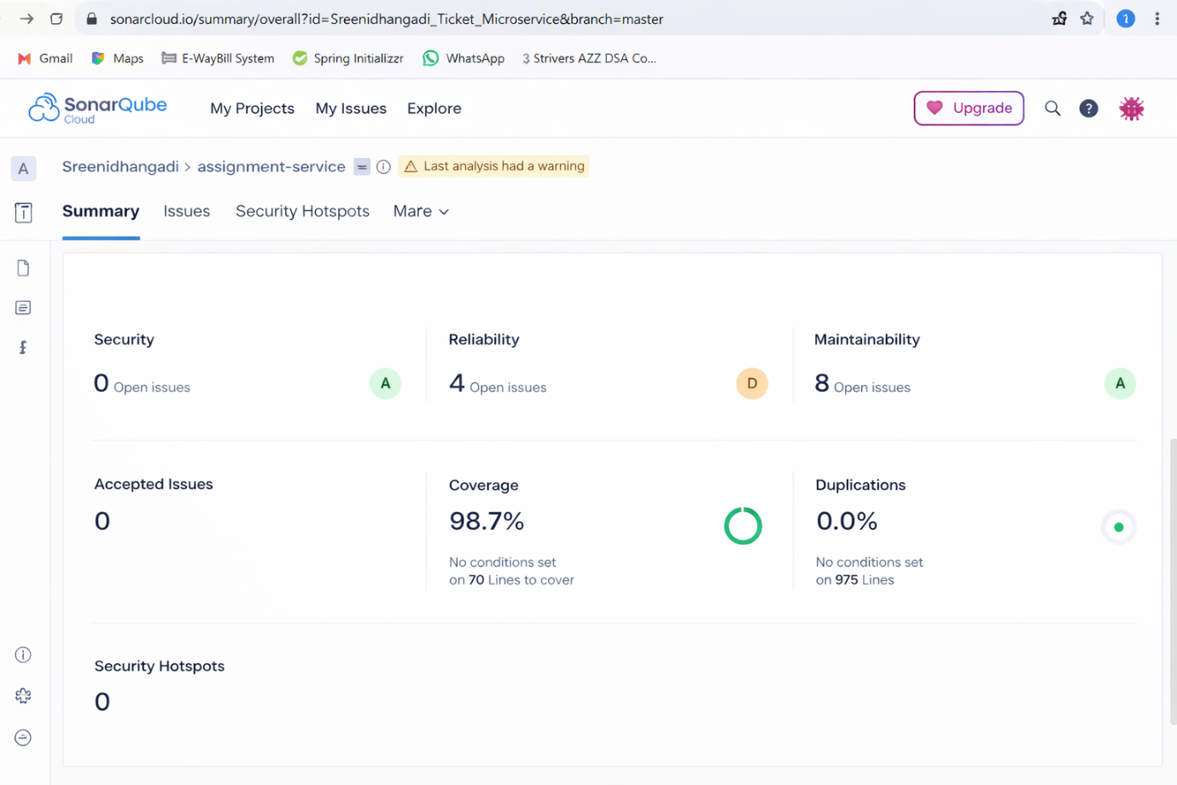  
  
**CIRCUIT BREAKER**  
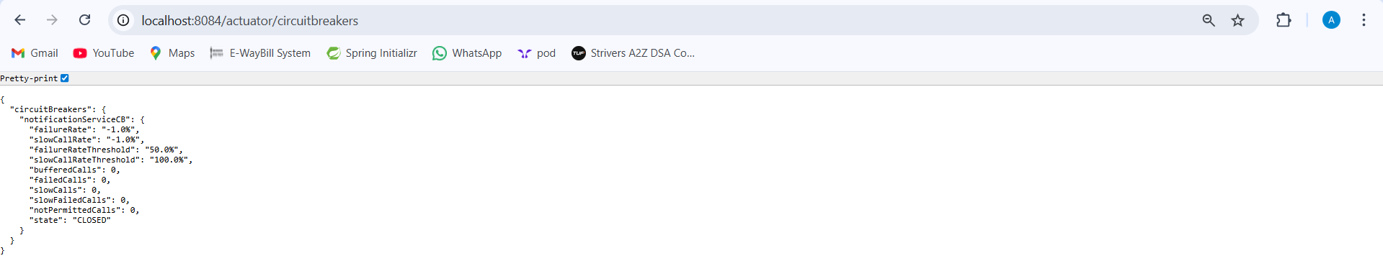

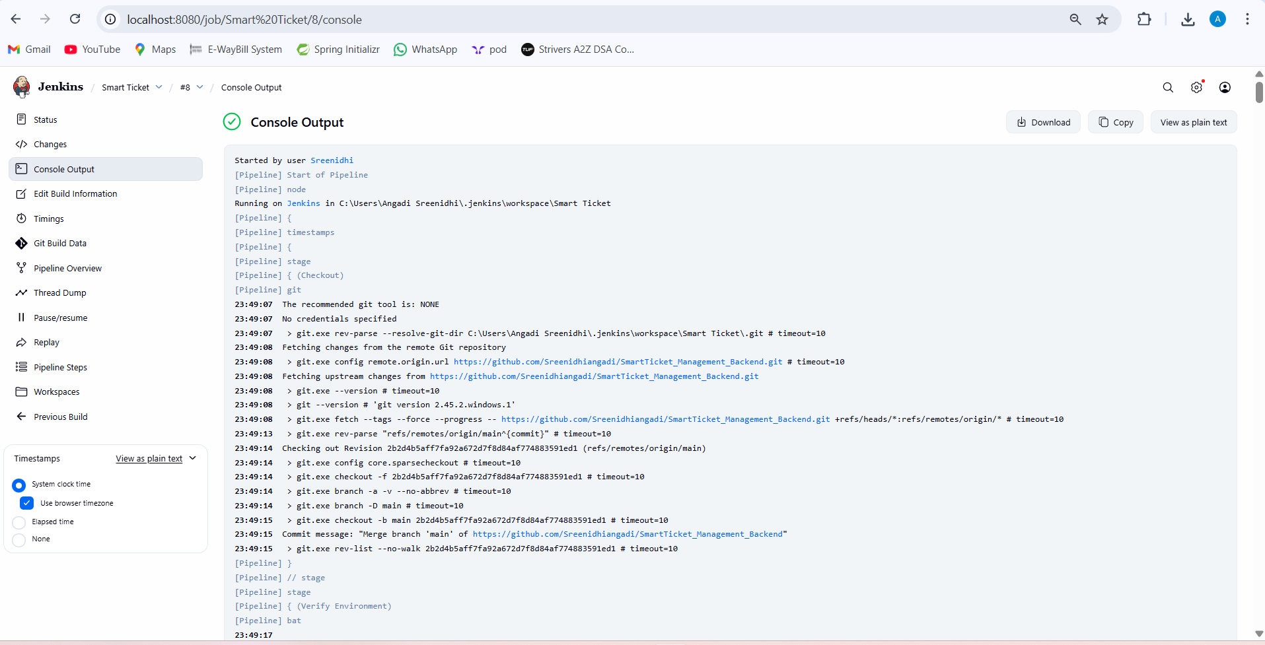**JENKINS**

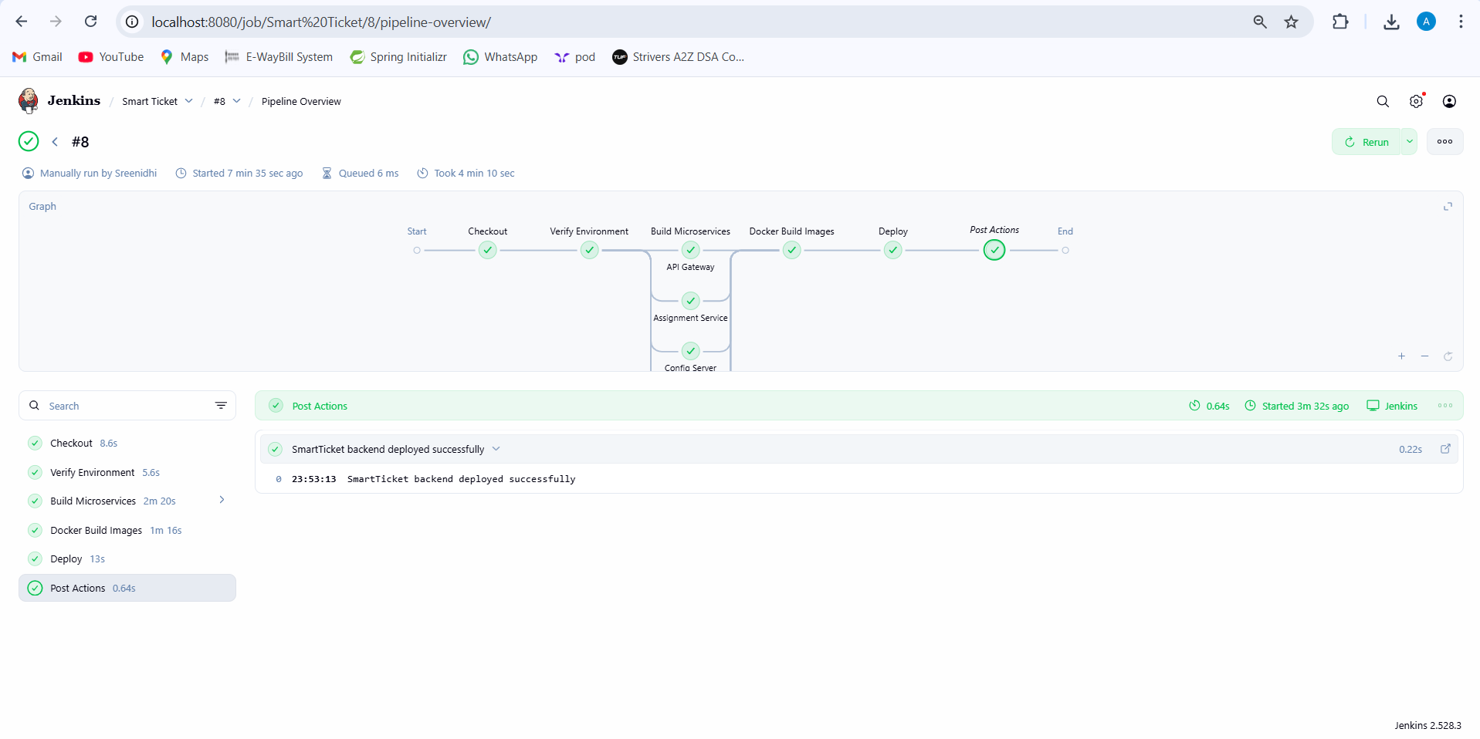

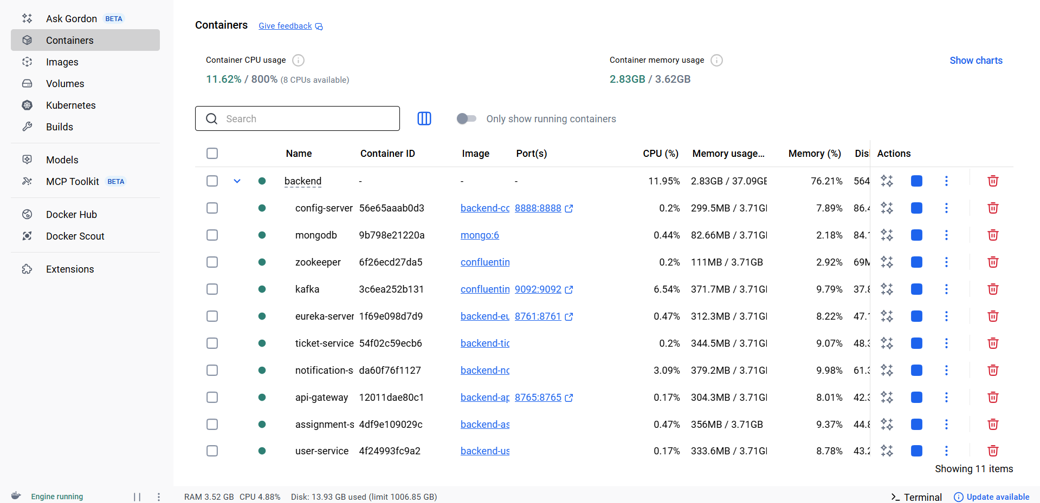**Docker Desktop**

**Architecture Diagram**

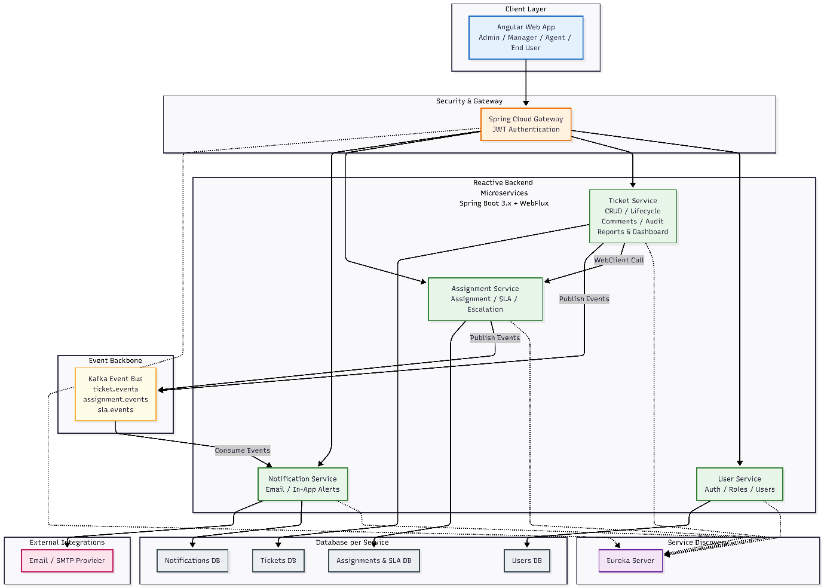

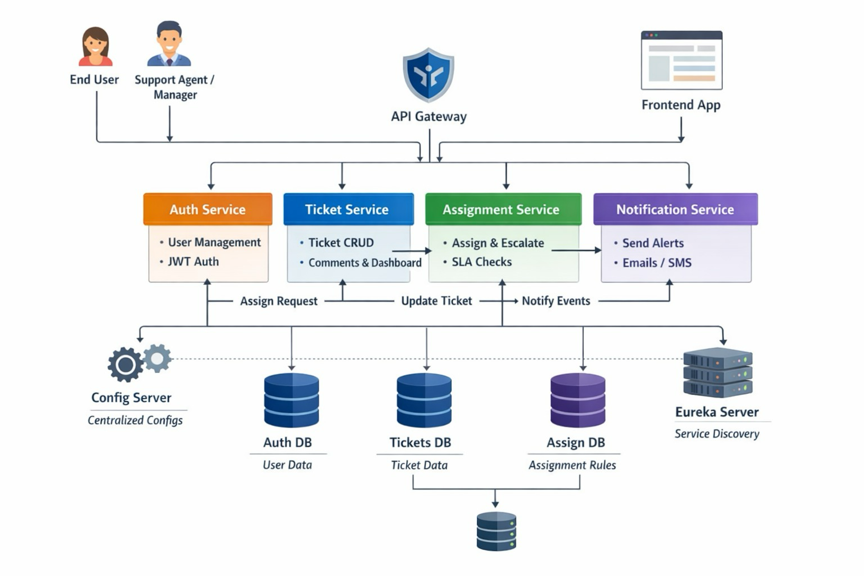

**SEQUENCE DIAGRAMS:**

1)USER CREATES A TICKET

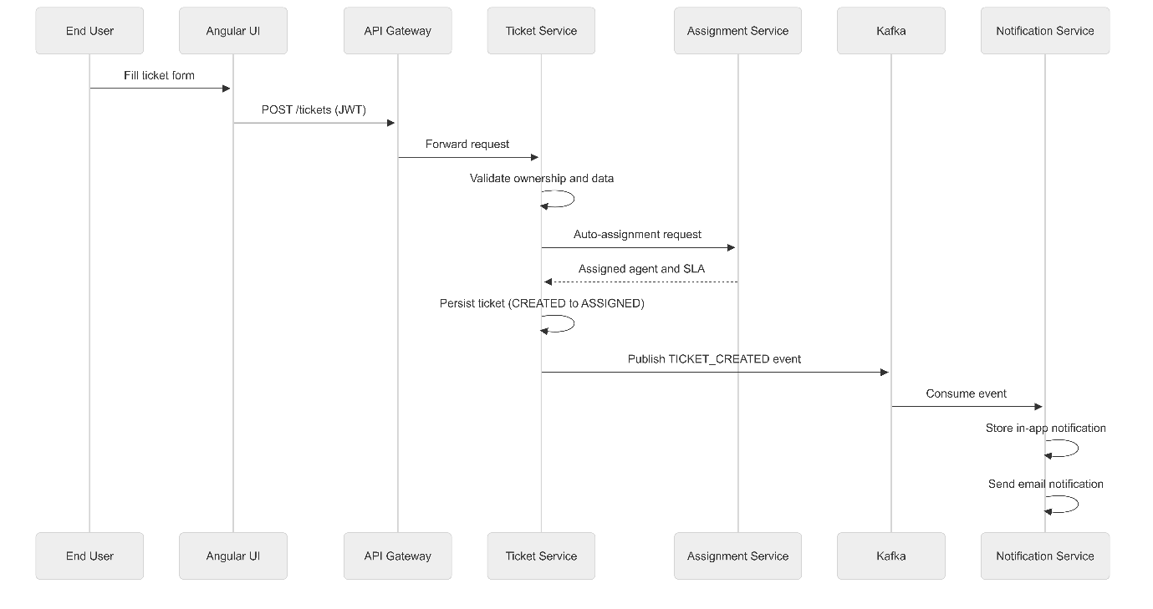

2) SUPPORT MANAGER MANUALLY ASSIGNS TICKET

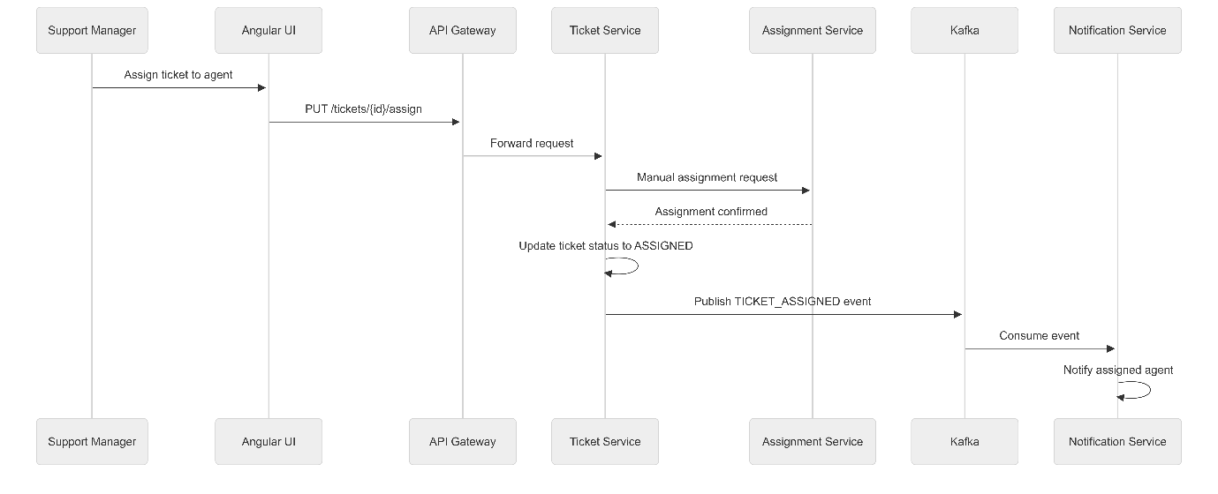

3) SUPPORT AGENT WORKS & RESOLVES TICKET

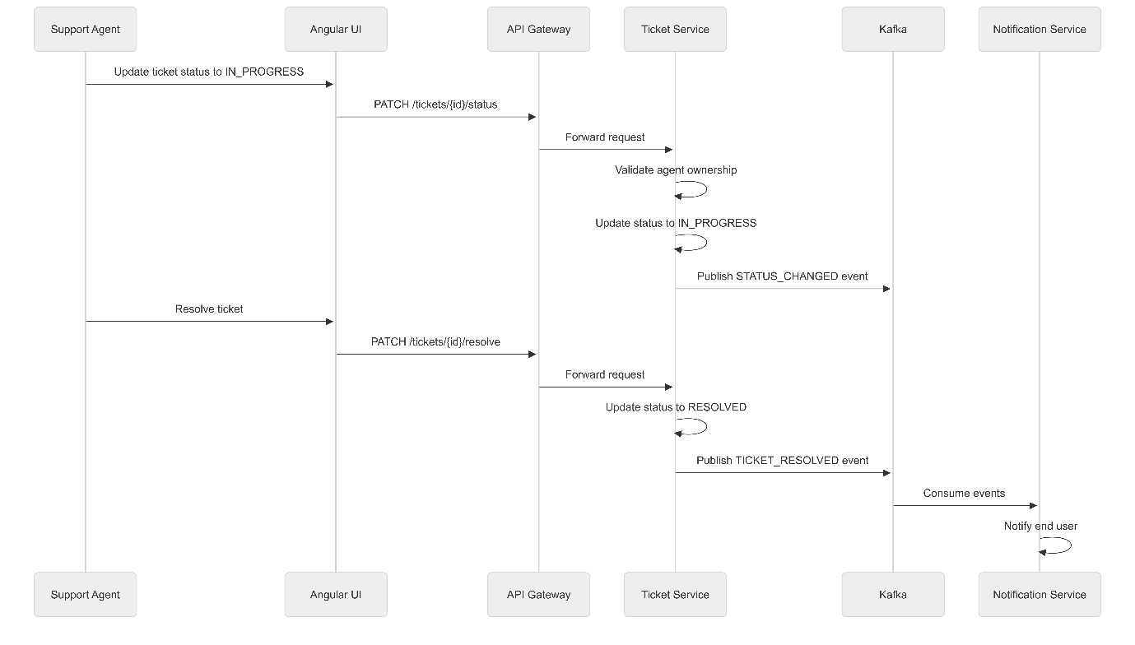

4)Complete application:

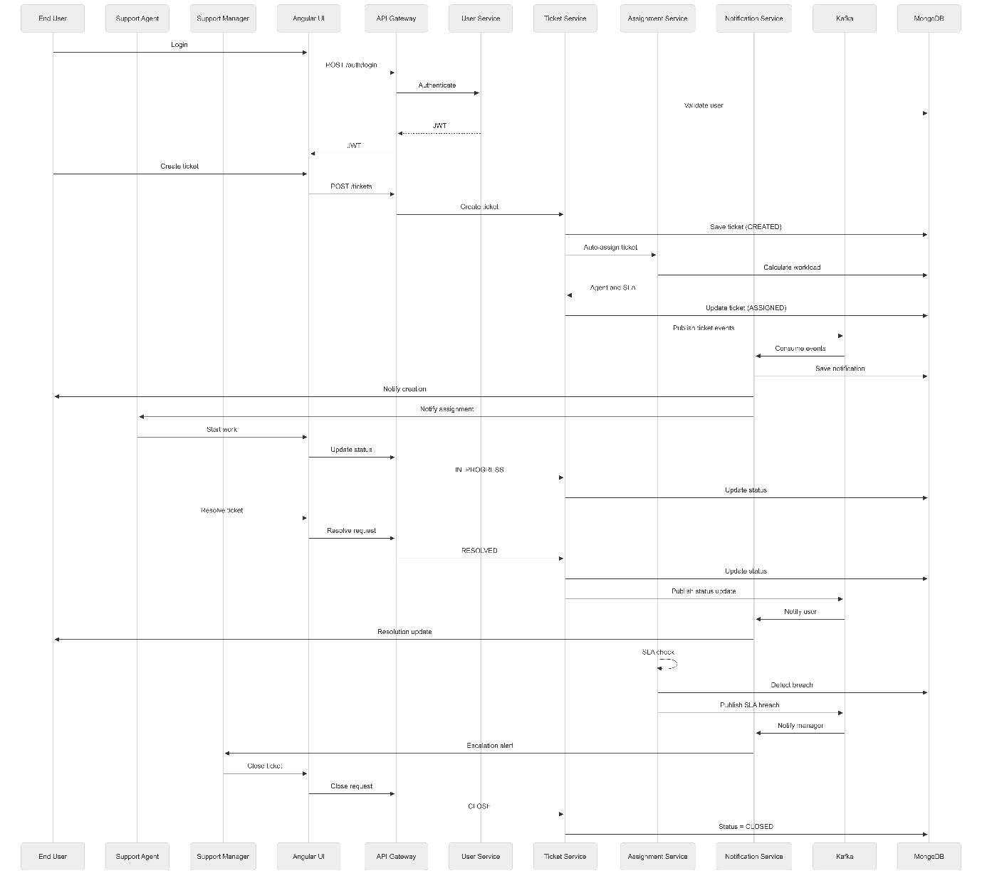

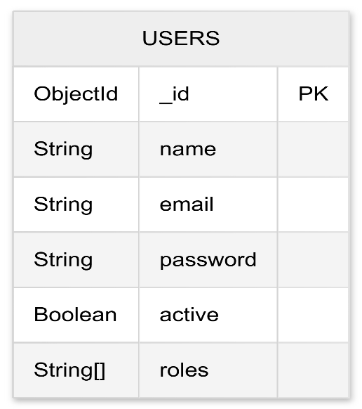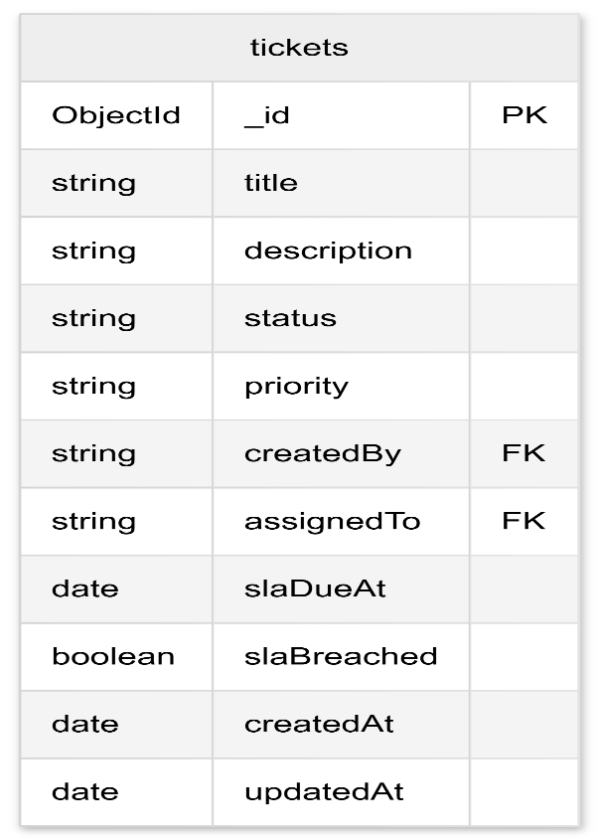**DATABASE STRUCTURE**  
1)Ticket db  
  
  
  
  
  
  
  
  
  
  
  
  
  
  
  
  
  
  
  
  
2) User db  
  
  
  
  
  
  
  
  
  
  
  
  
  
  
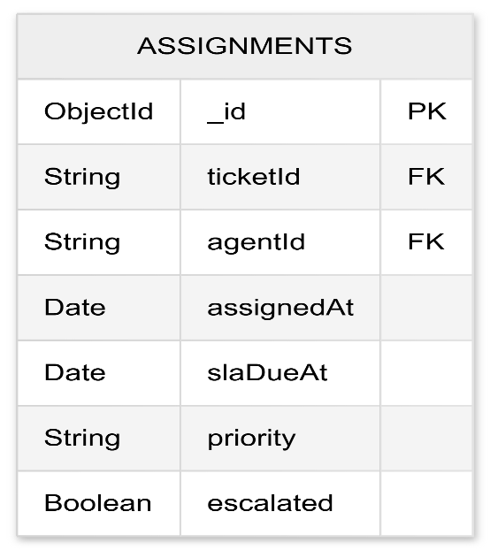3)Assignment db

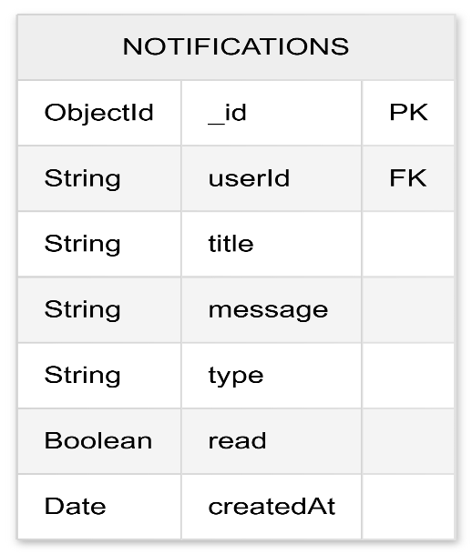  
4)Notification db  
5)Complete db structure  
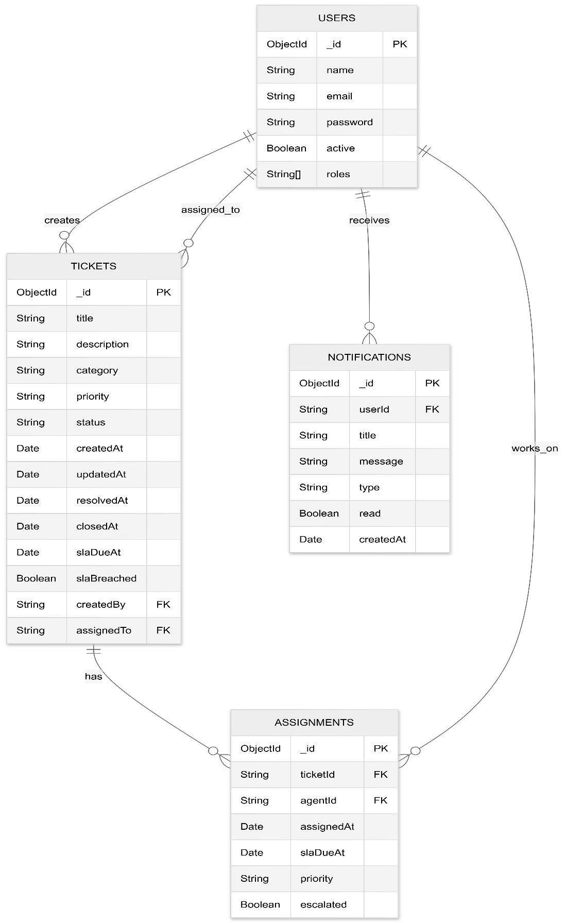

CLASS DIAGRAMS  
1)Ticket

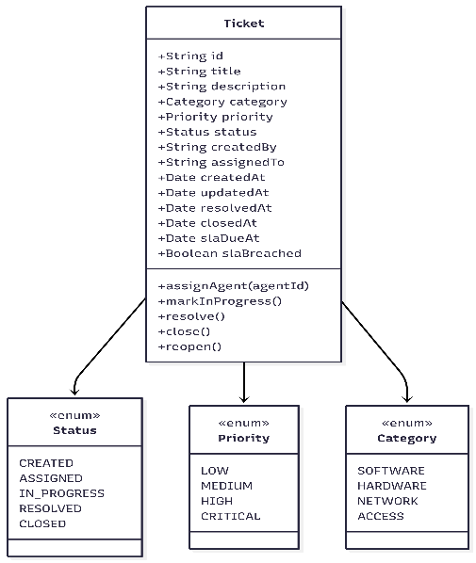

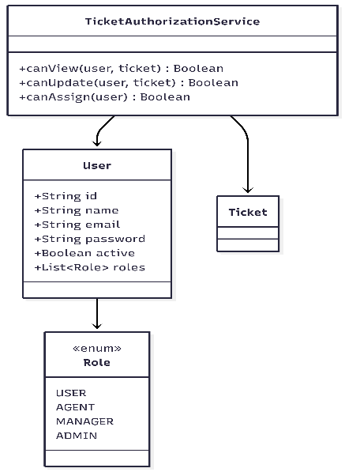2)User

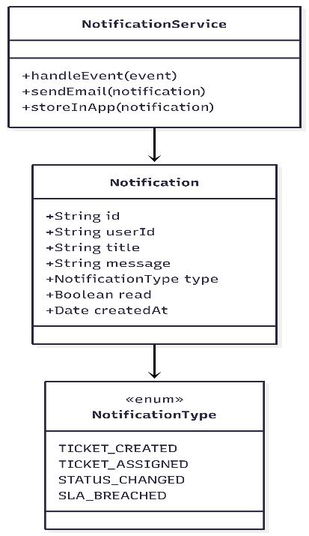3)Notification  
  
  
  
  
  
  
  
  
  
  
  
  
 **Implementation screenshots**

1)**User Register** (Validations): 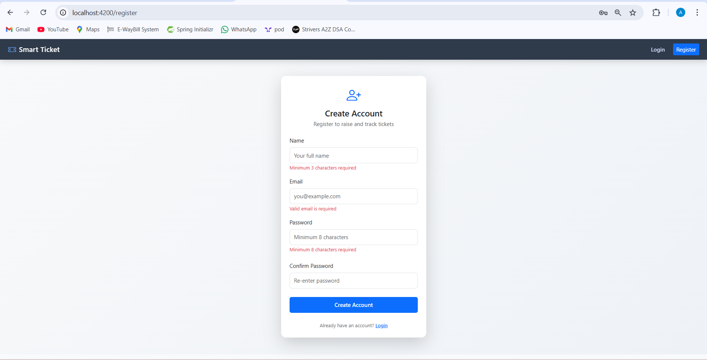

2)**User already exists**:  
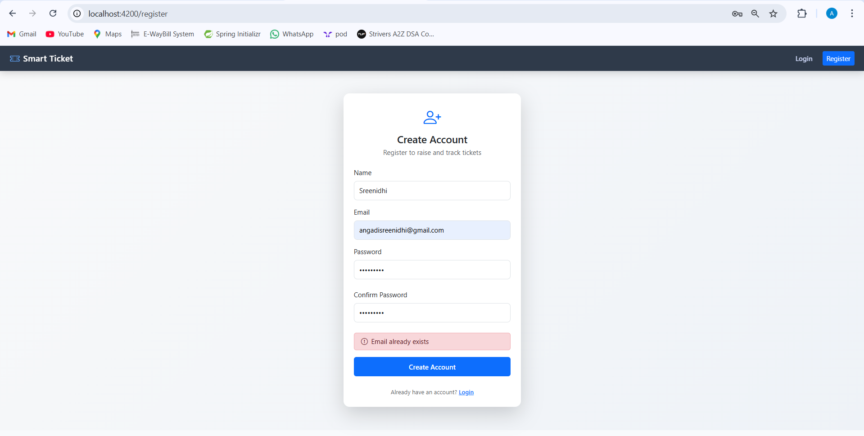

3)Succesful registration redirects to login:  
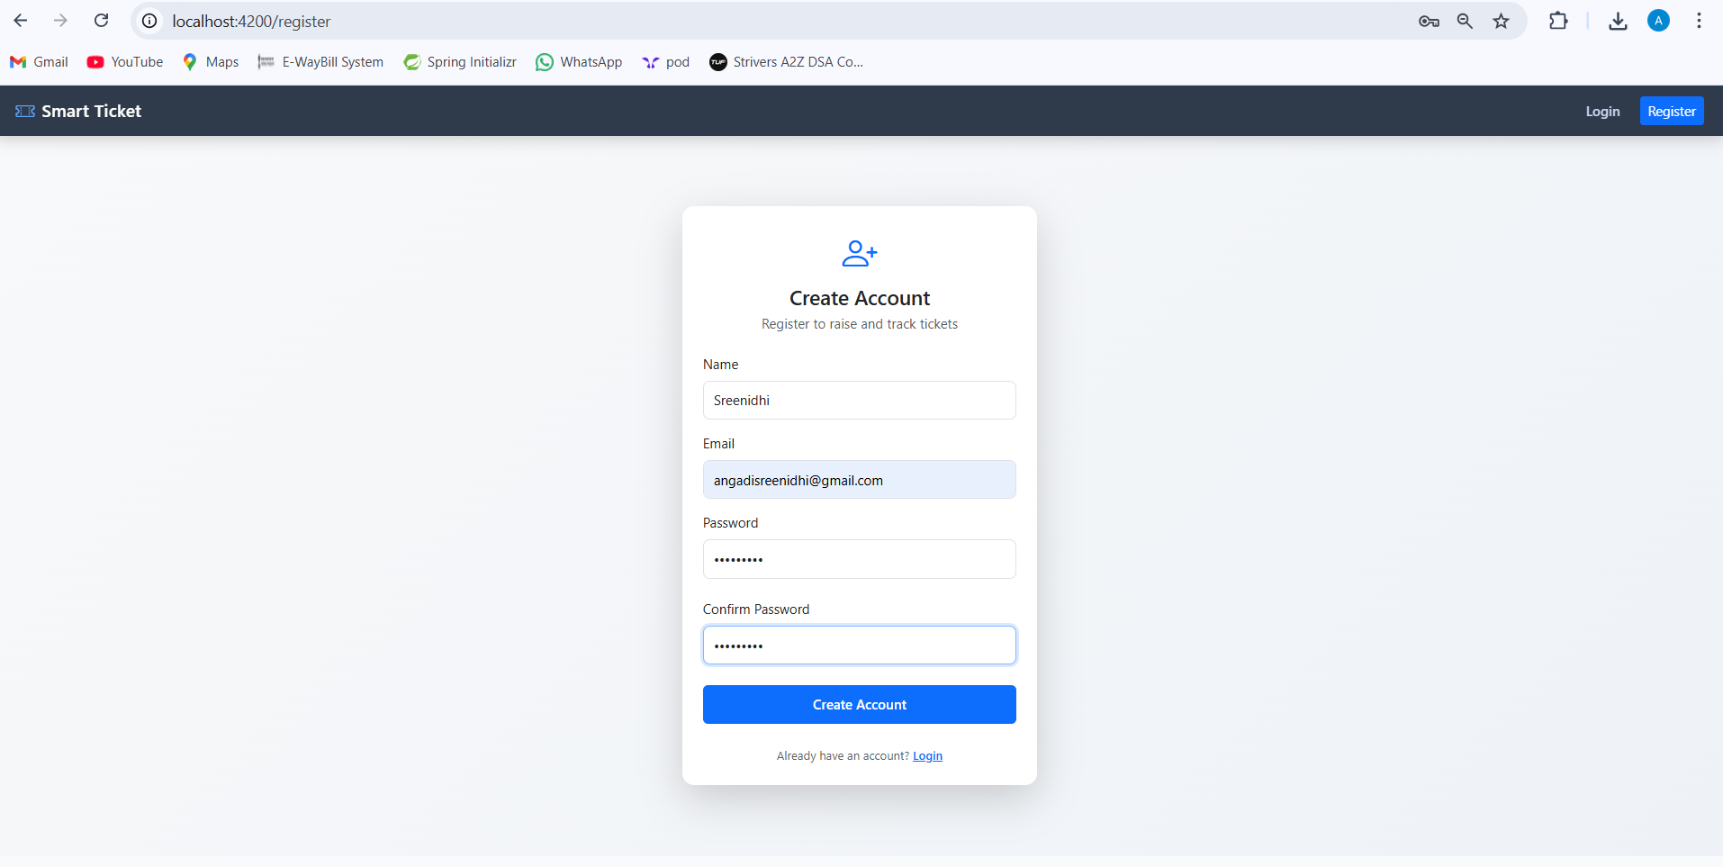

4)**User login** (Validations):  
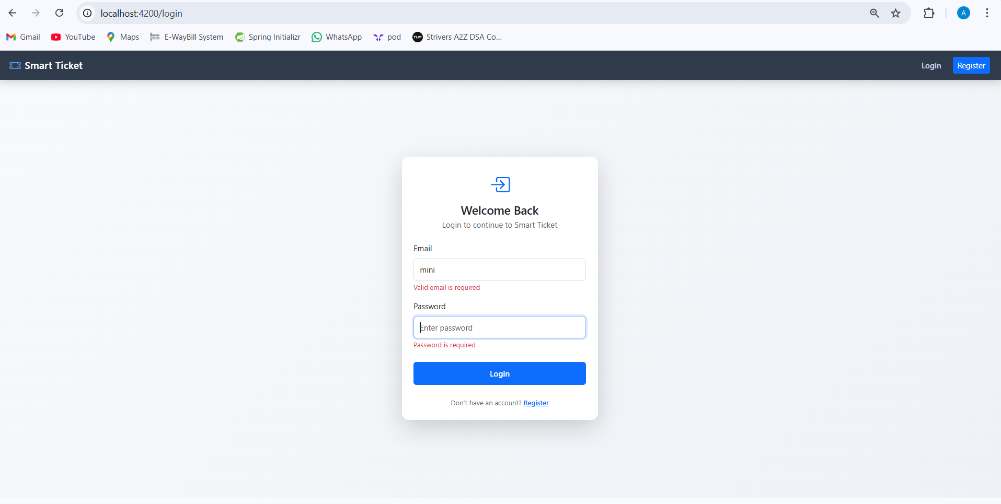

5)successful login  
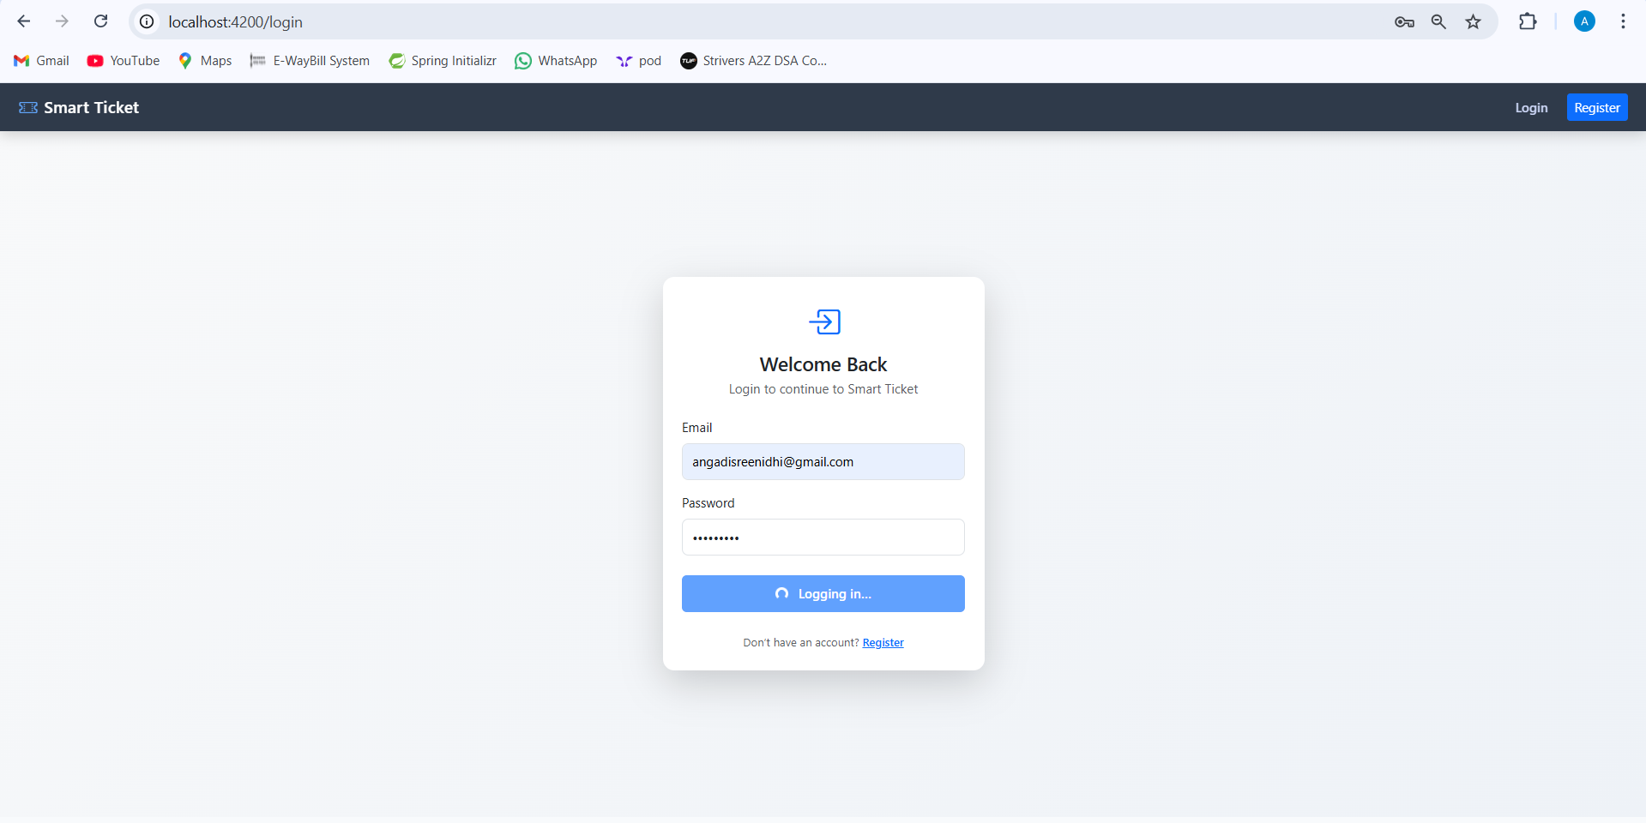  
6) Home Page

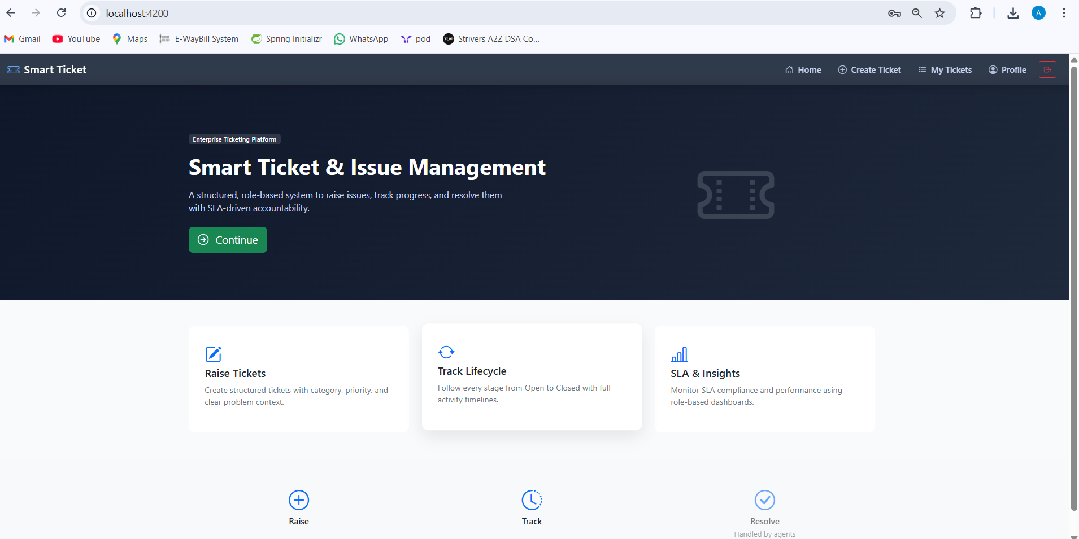

7)User raises an issue:  
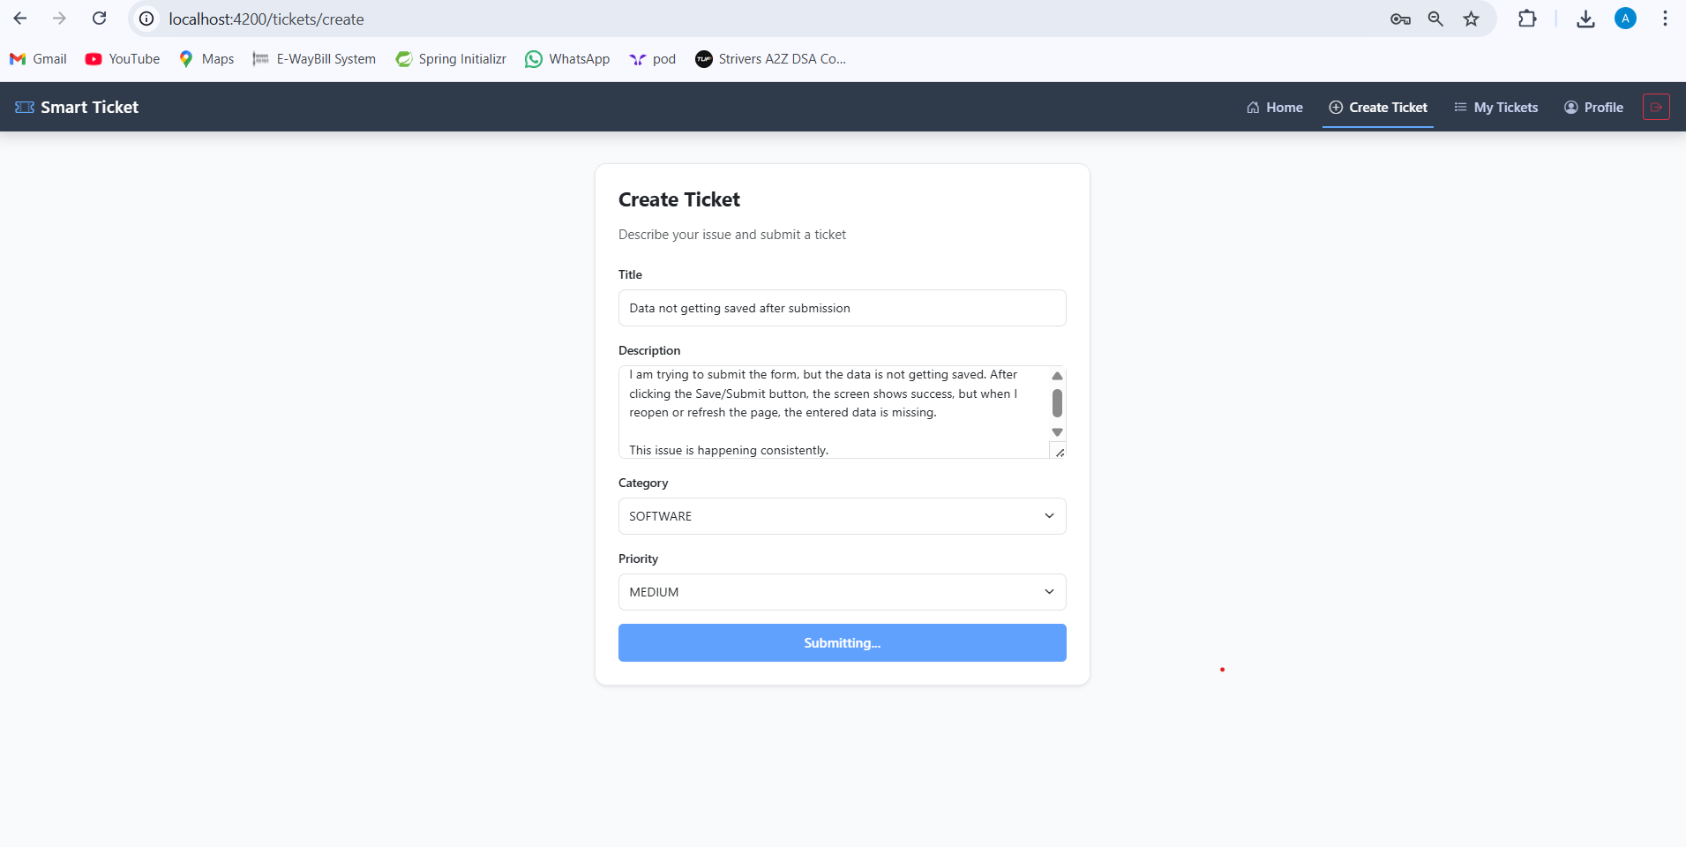  
8)Ticket details  
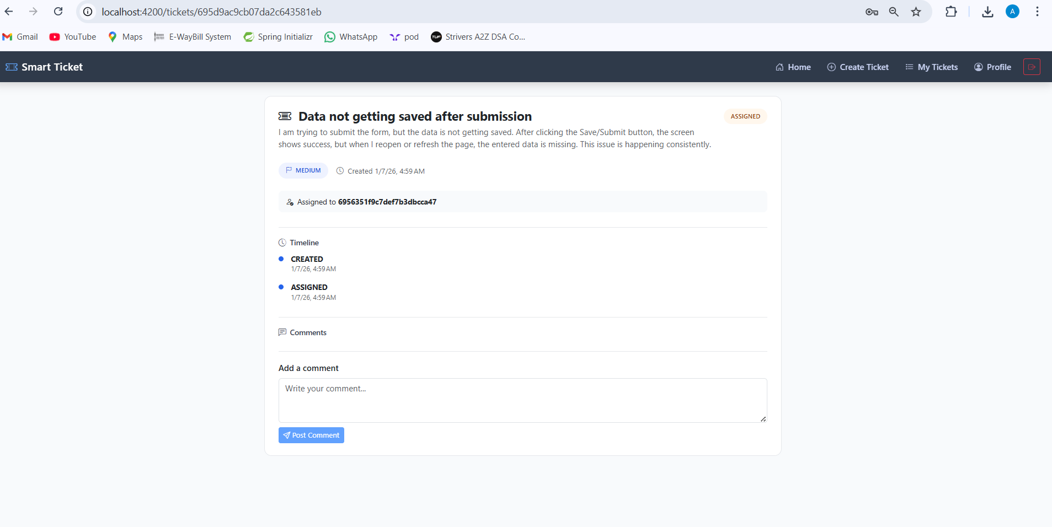

9)User Tickets  
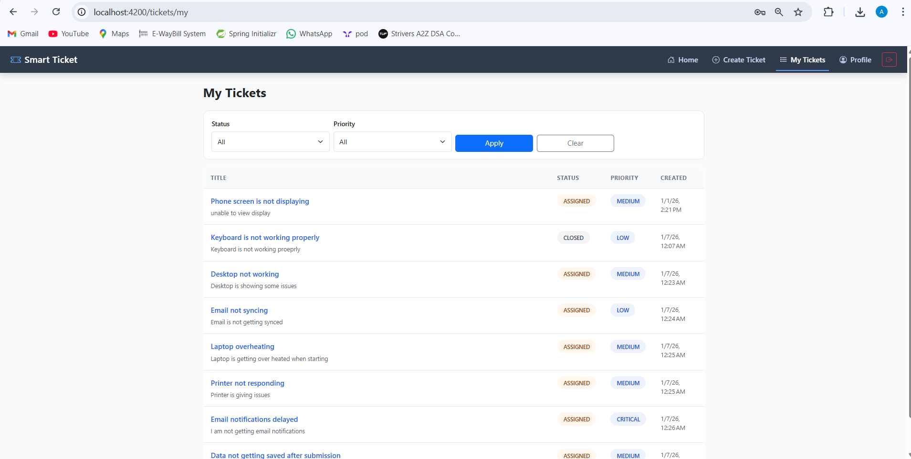  
10)User Tickets with filtering  
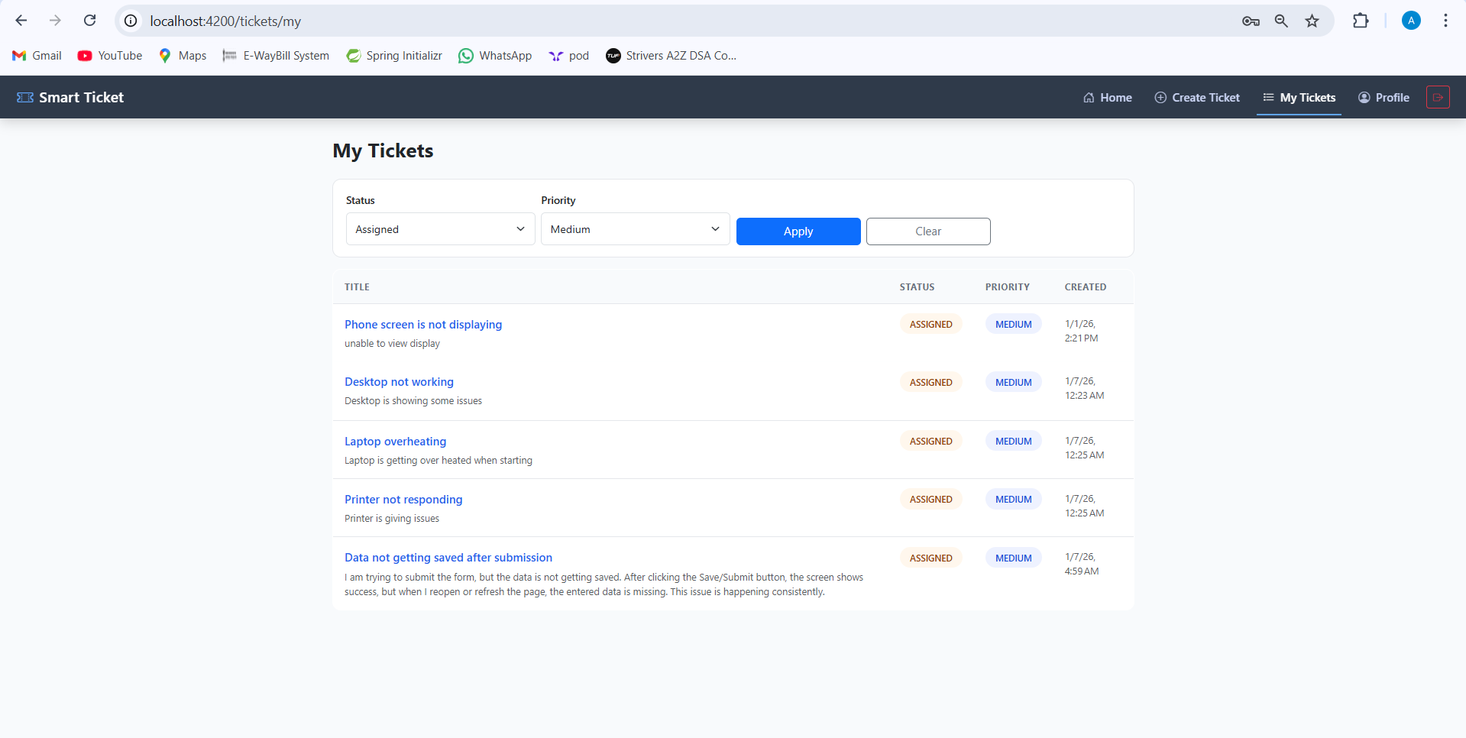

11)Profile page

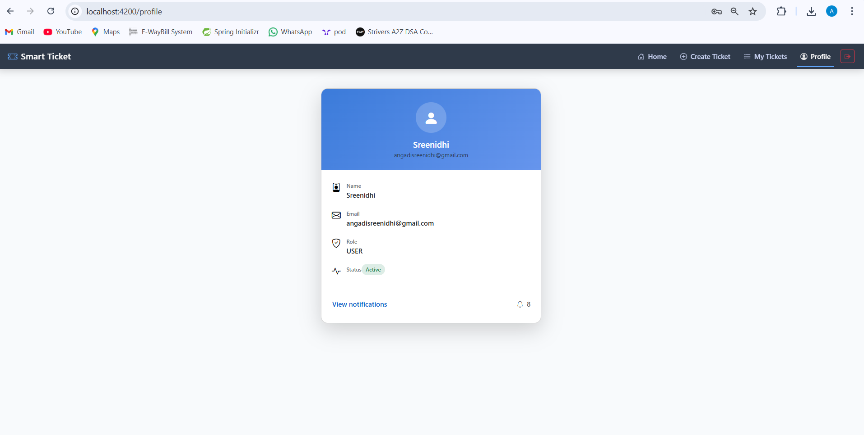  
12)View in app notifications  
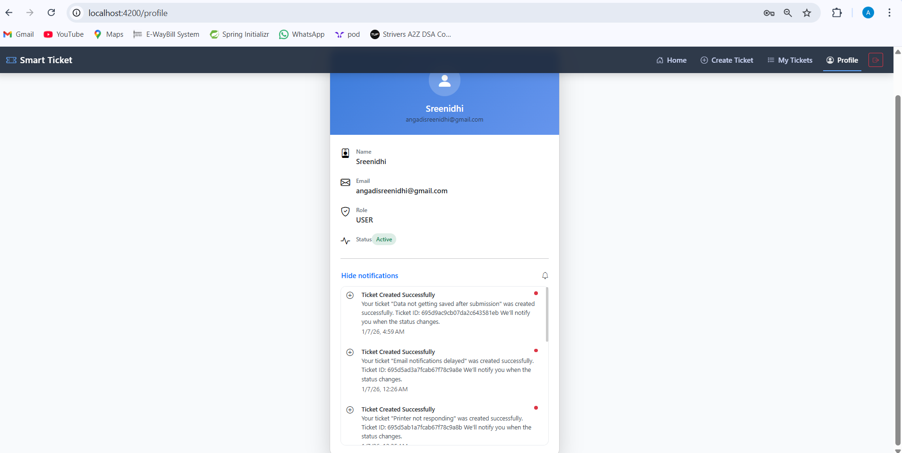

13)Agent Ticket Queue  
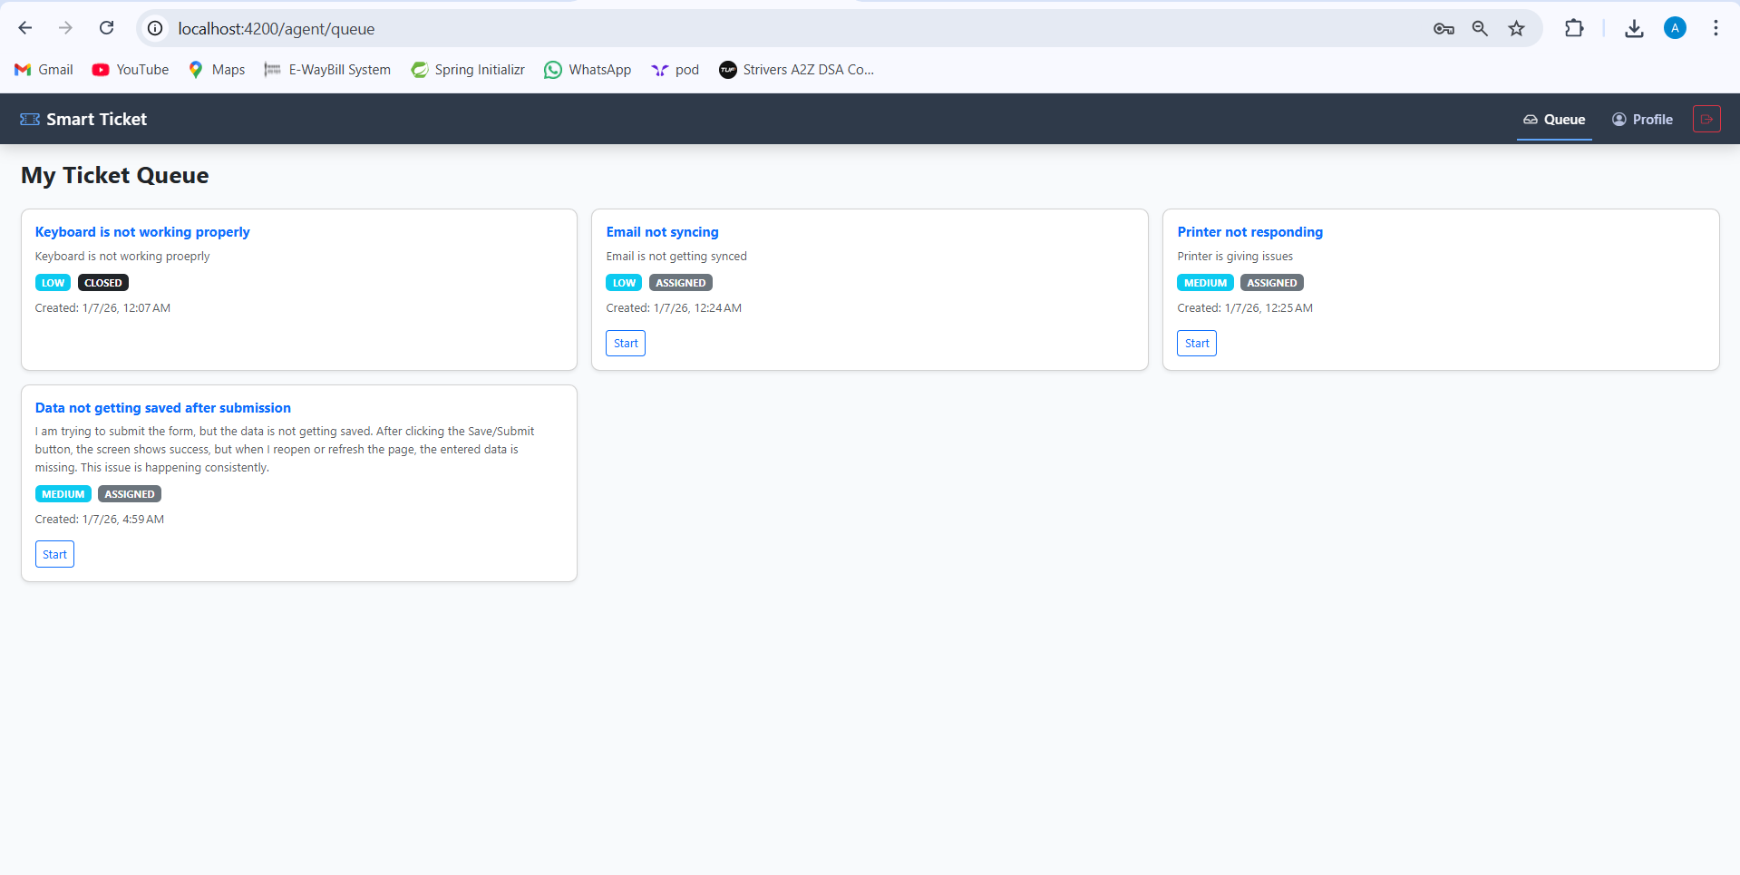  
14)Agent profile with in app notifications  
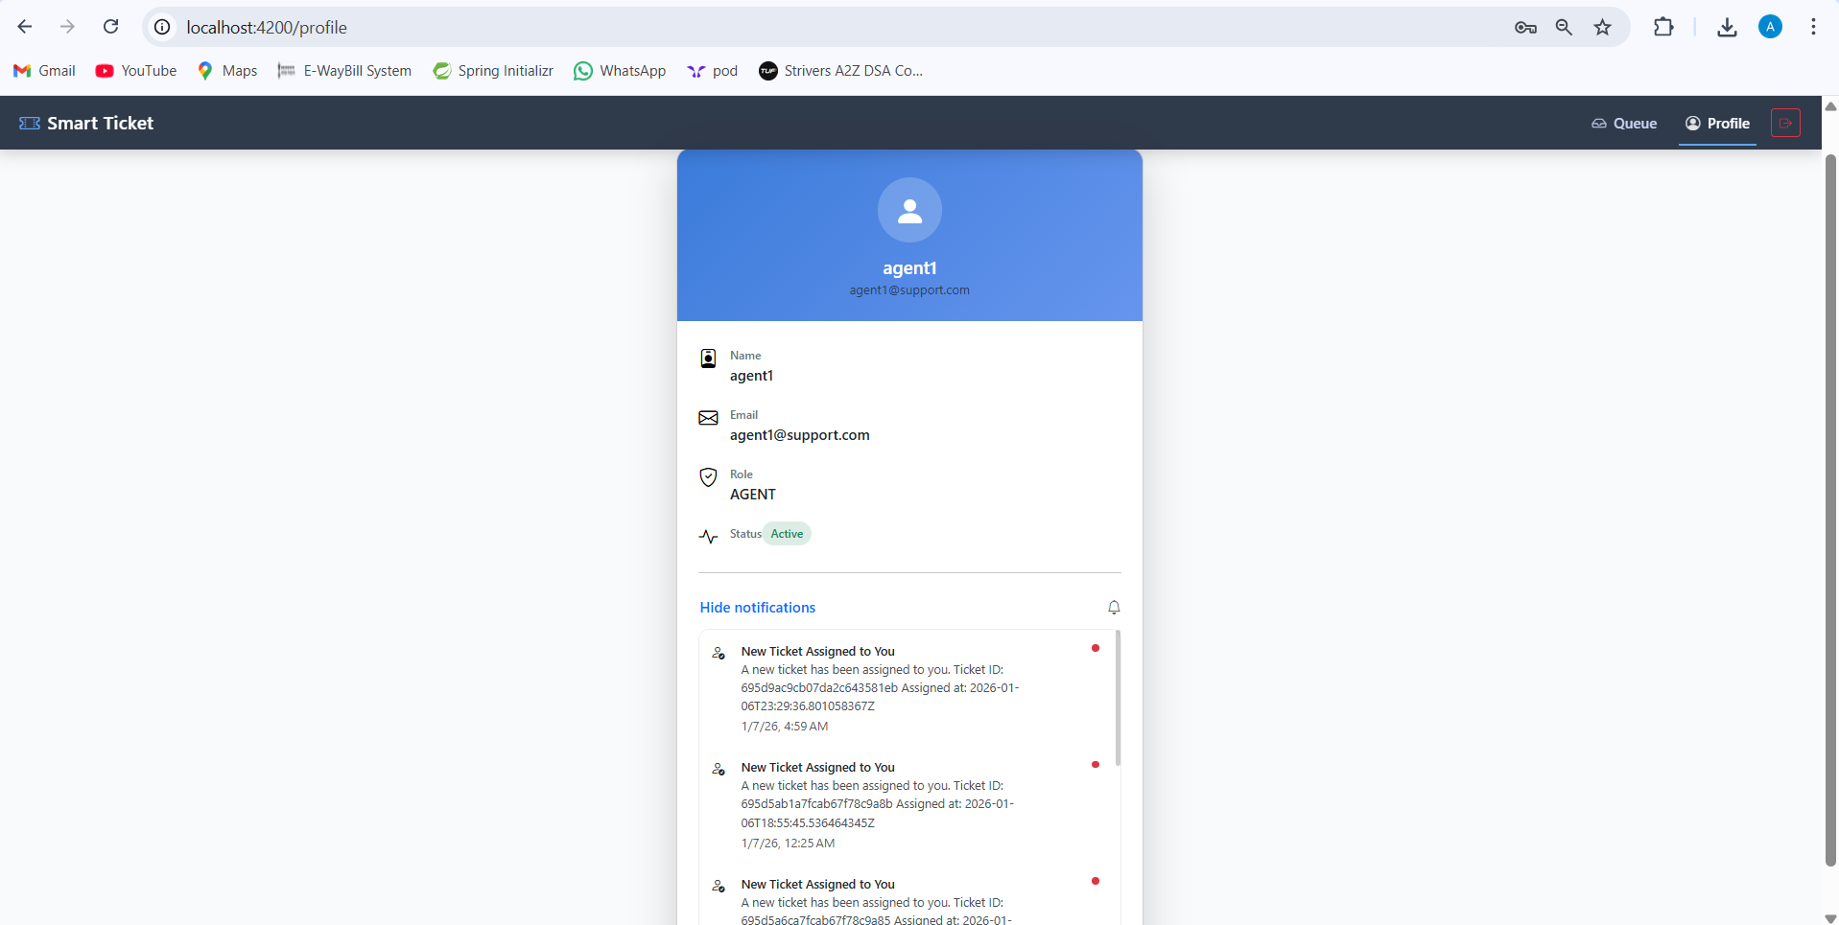

15)Manager Dashboard

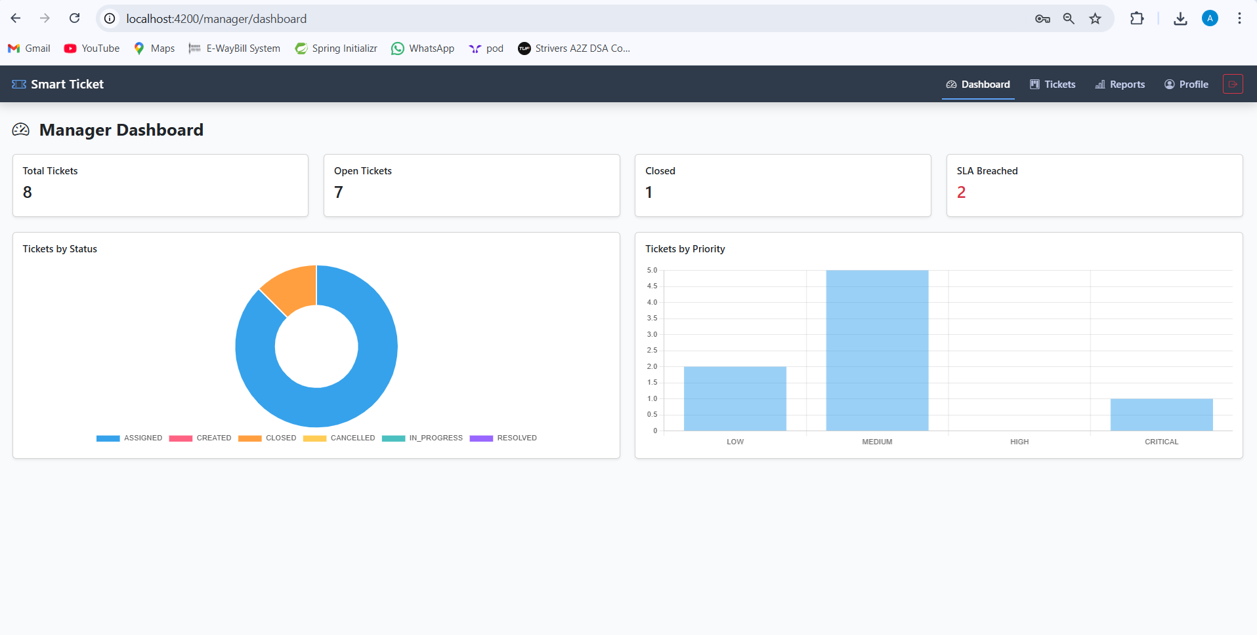  
16)Manager (view all tickets)  
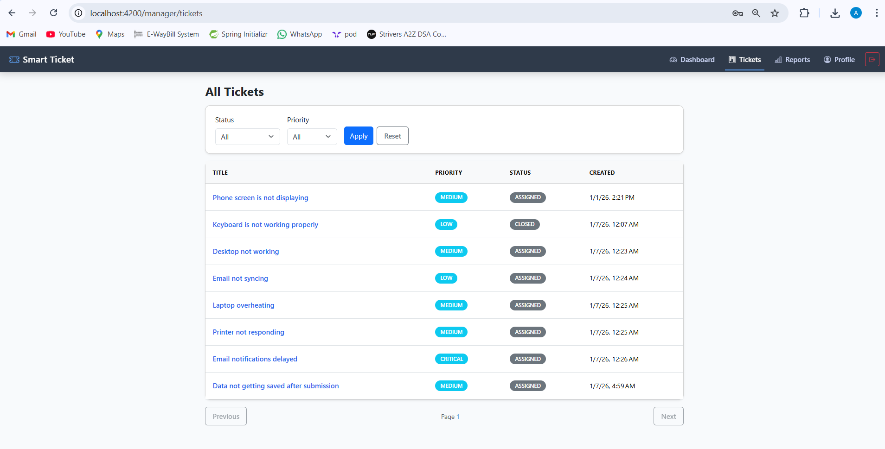

17)Manager actions(reassigning)  
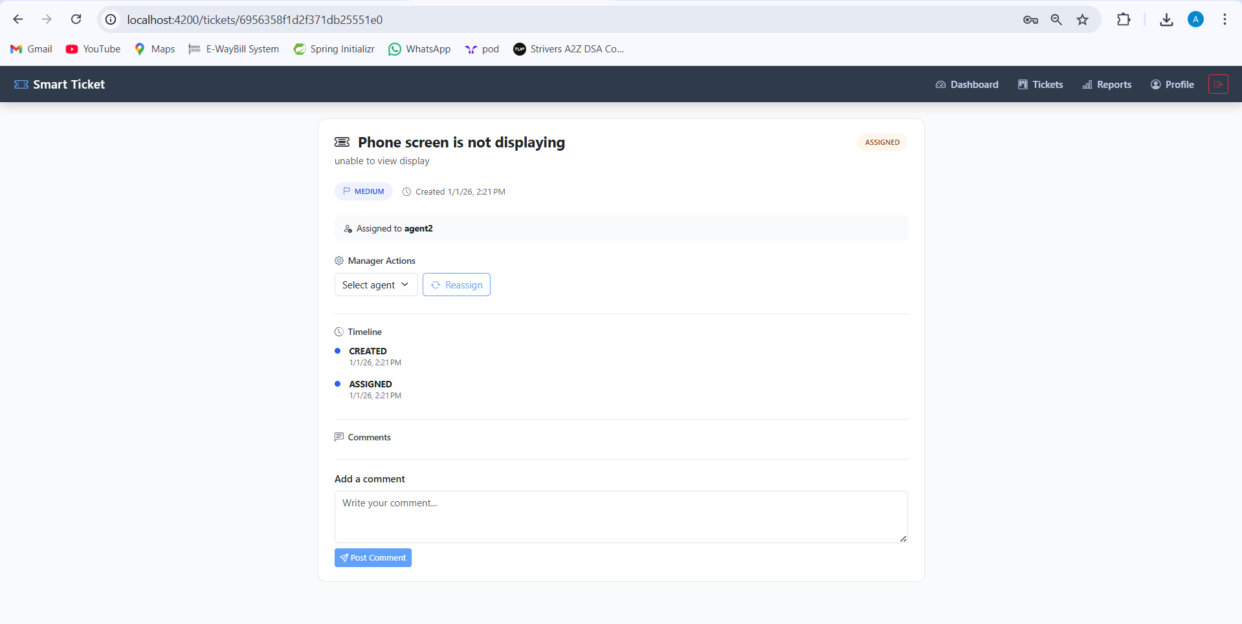  
18)Reports and Analytics  
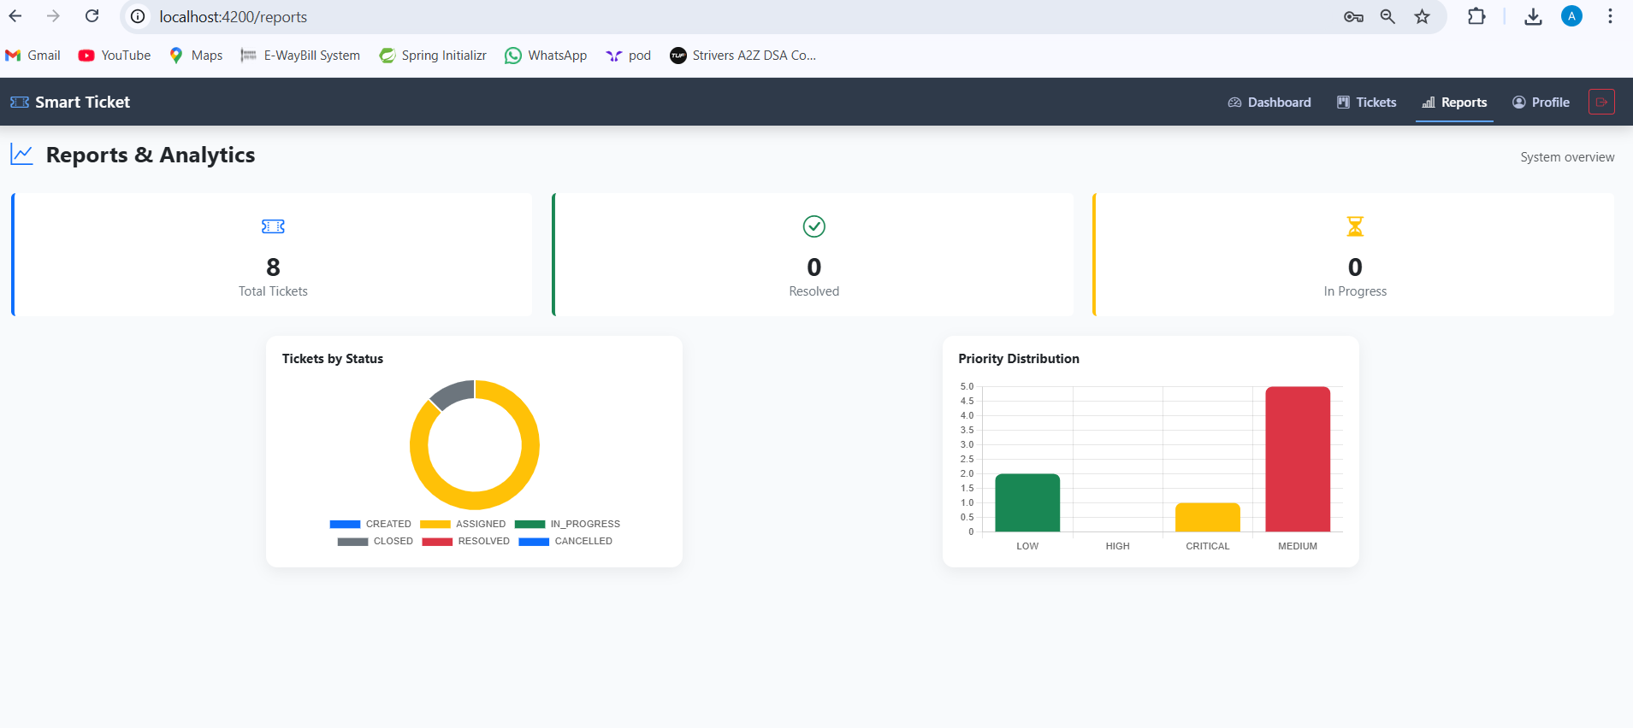  
19)Admin Dashboard  
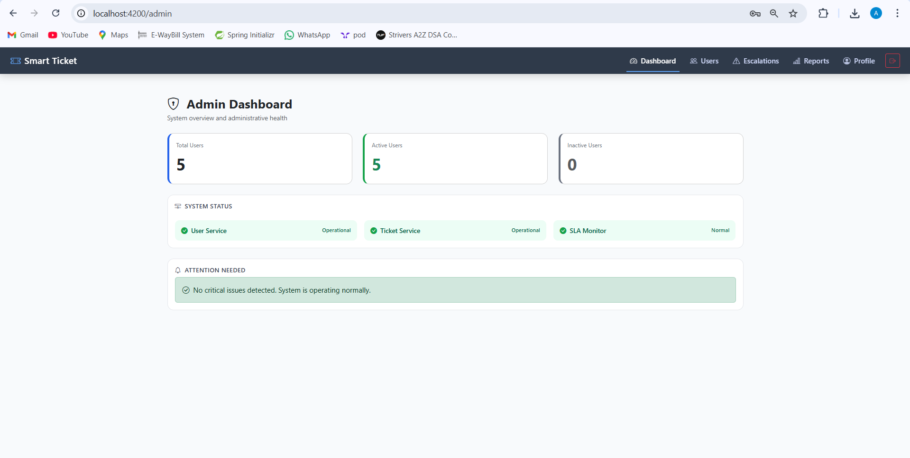

20)Admin panel  
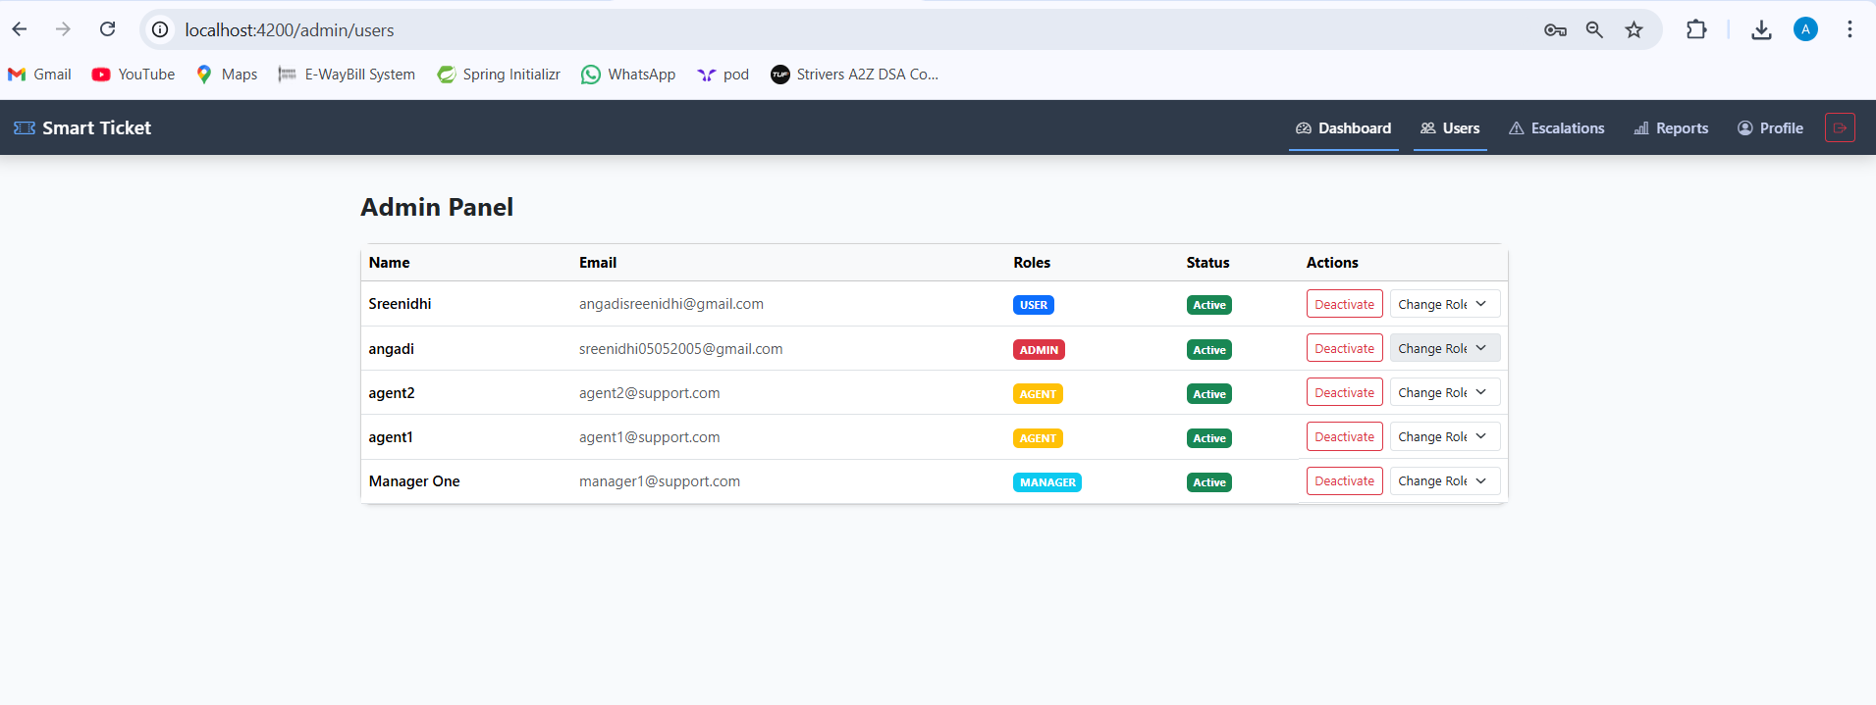  
21)Reports and Analytics  
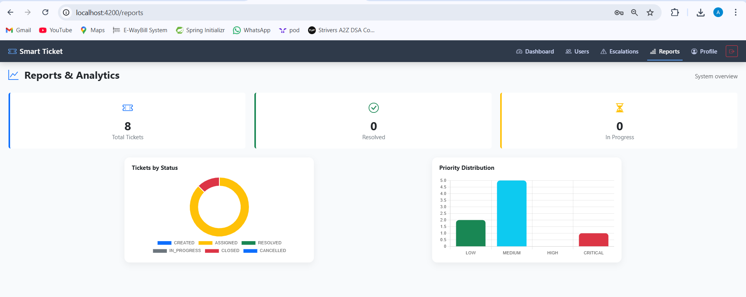  
22)Email Notifications  
